
PUBLIC NOTICE
Public notice is hereby given that the Council of TOWN OF WOLSLEY intends to adopt a bylaw under The Planning and Development Act, 2007 to amend Bylaw No. #2-2025 known as the Zoning Bylaw.
INTENT
The proposed bylaw will amend the Zoning District Map referred to in part 6.2.
AFFECTED LAND
The affected land is legally described as part of the Parcel B Plan D5439 shown on a plan of proposed subdivision dated April 24th, 2025 and signed by Trenton D. Wahl S.L.S. as shown on the following map.
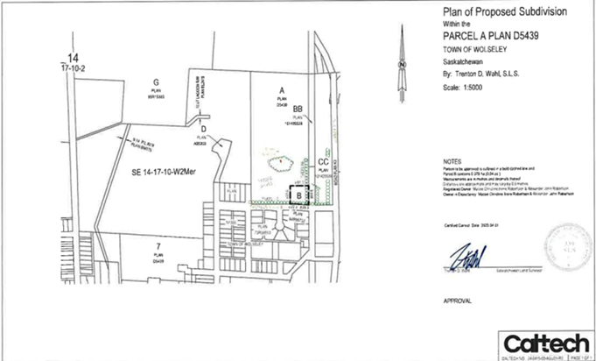
REASON
The reason for the amendment is to rezone the property to RI-Residential Single Dwelling District to allow for a residential home to be erected on the property.
PUBLIC INSPECTION
Any person may inspect the bylaw at the municipal office at 610 Varennes St. between 8:30 am and 4:30 pm Monday to Friday, excluding statutory holidays. Copies are available at cost.
PUBLIC HEARING
Council will hold a public hearing on September 16th at 7:00 pm at Wolseley Town Hall, 206 Richmond Street, Wolseley SK to hear any person or group that wants to comment on the proposed bylaw. Council will also consider written comments received at the hearing or delivered to the undersigned at the municipal office before the hearing.

Issued at the TOWN OF WOLSELEY this August 31st, 2026

Keri Gardner, CAO

